**Git Punishment (21st Oct 2024)**

**Sahil Shah**

**150096724032**

1. **Steps:**
2. Start terminal
3. 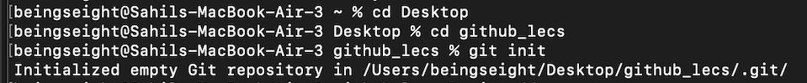

(to initialize, the path and later a repository is initialized)

Git init initializes a new repository

After that there is blank so it initializes empty repository instead by mentioning a directory we can initialize in specific directory

Adding a -bare will create a bare repository

1. 

(git adds all the changes with git add .) command,

And a commit is committed whereas “FirstCommit” in which the “” in between is the message to describe change of the commit

1. 

Connects the local repository to a remote repository

1. 

Push the changes to remote repository

1. 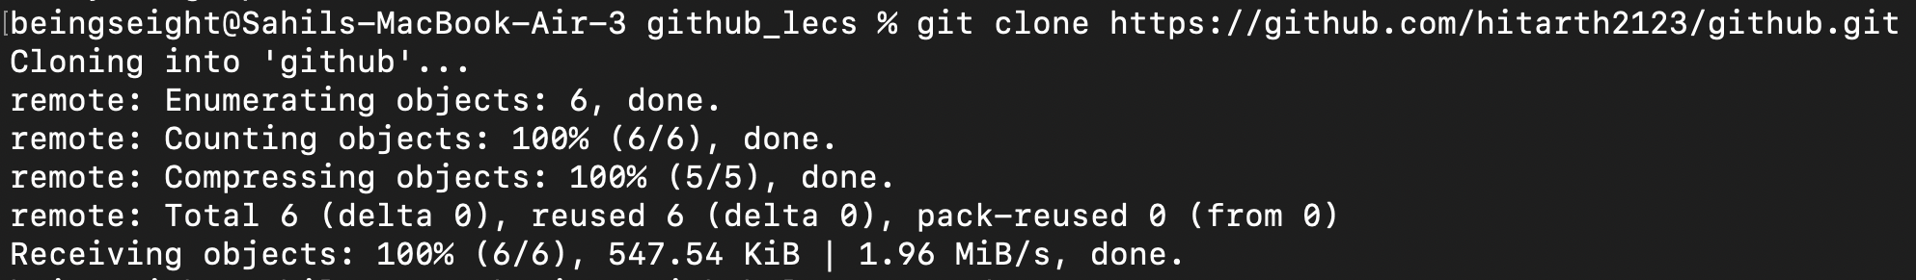

Clones a repository of someone else

Here it cloned a repository of my friend

1. 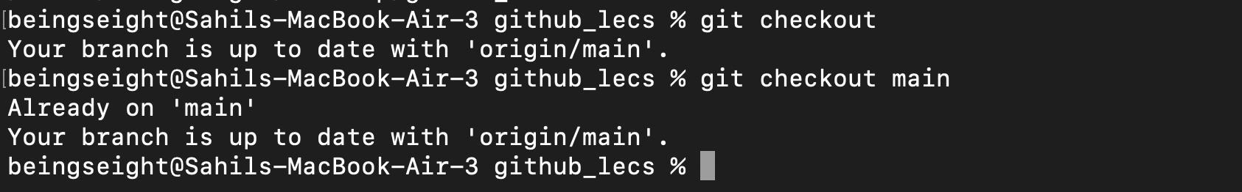

Checkouts the origin

Specifying main means checkouts the exact branch

**2. Creating 5 different directories with help of github command**

1. 

Create directory with mkdir and names it as docs,src,tests,assests and config individually

1. 

Pushes to the previous origin one

**3. Git – help**

1. -u for update
2. -M for moving or renaming branch
3. -f forces an action
4. –help for help
5. -C for running commands in different repositories without changing current directory

**4. Git help init**

**5. Git help clone**

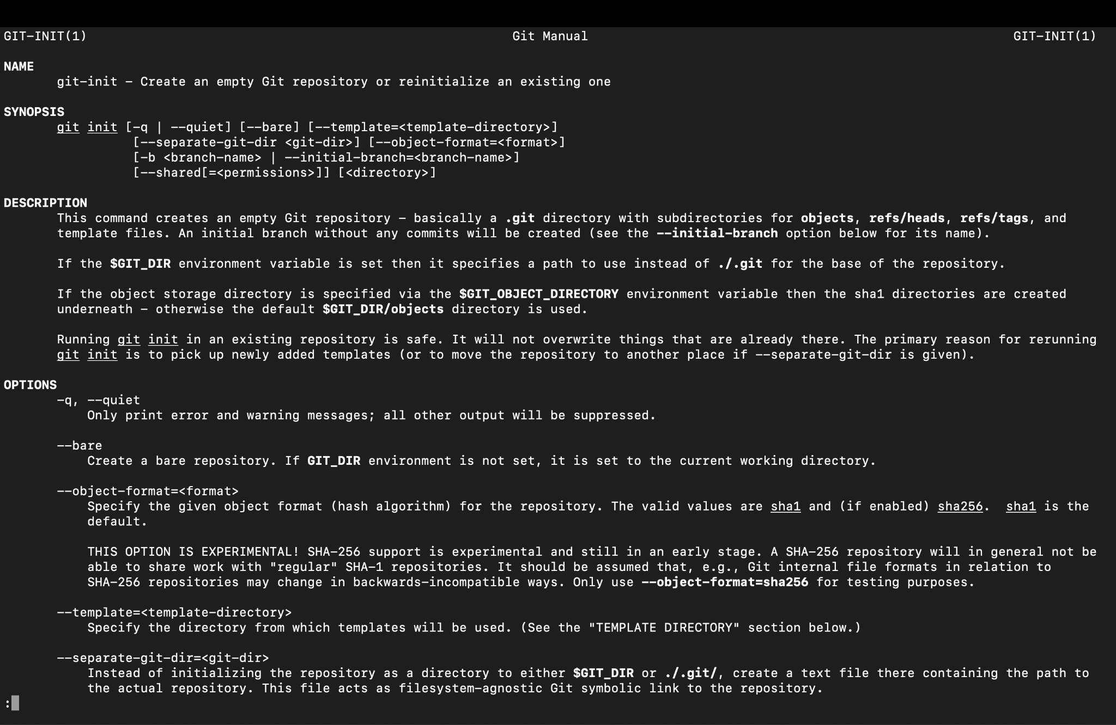

1. **Git config -help**

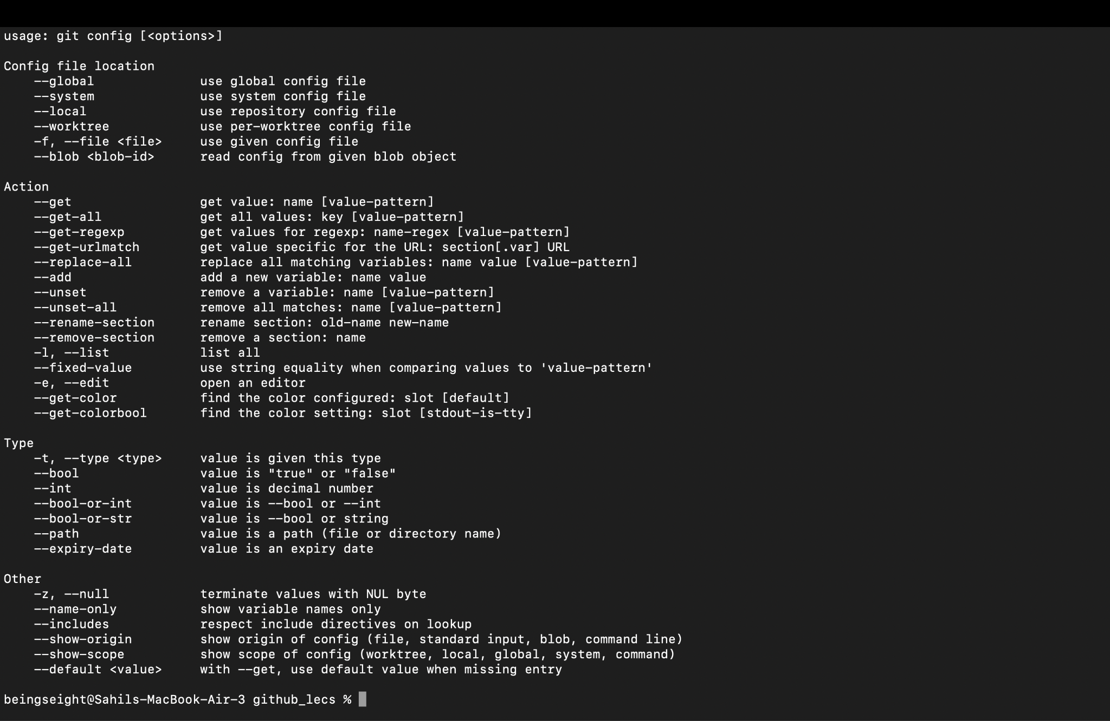

1. **Git help status**

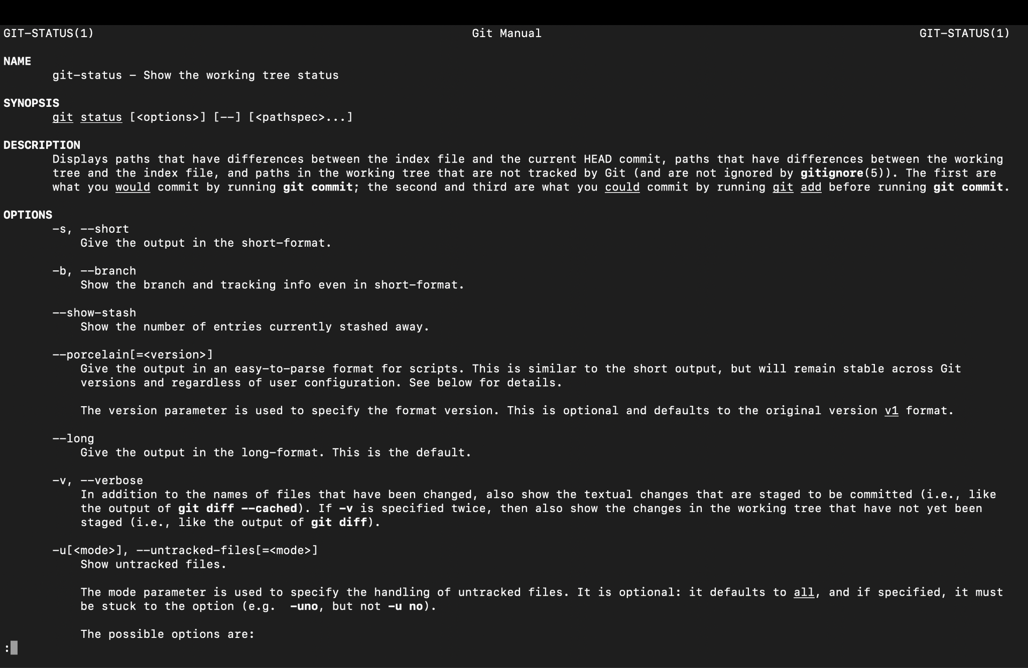

**–x–**